**LAB TASK 7: Manage access with RBAC**

**Task 1:**

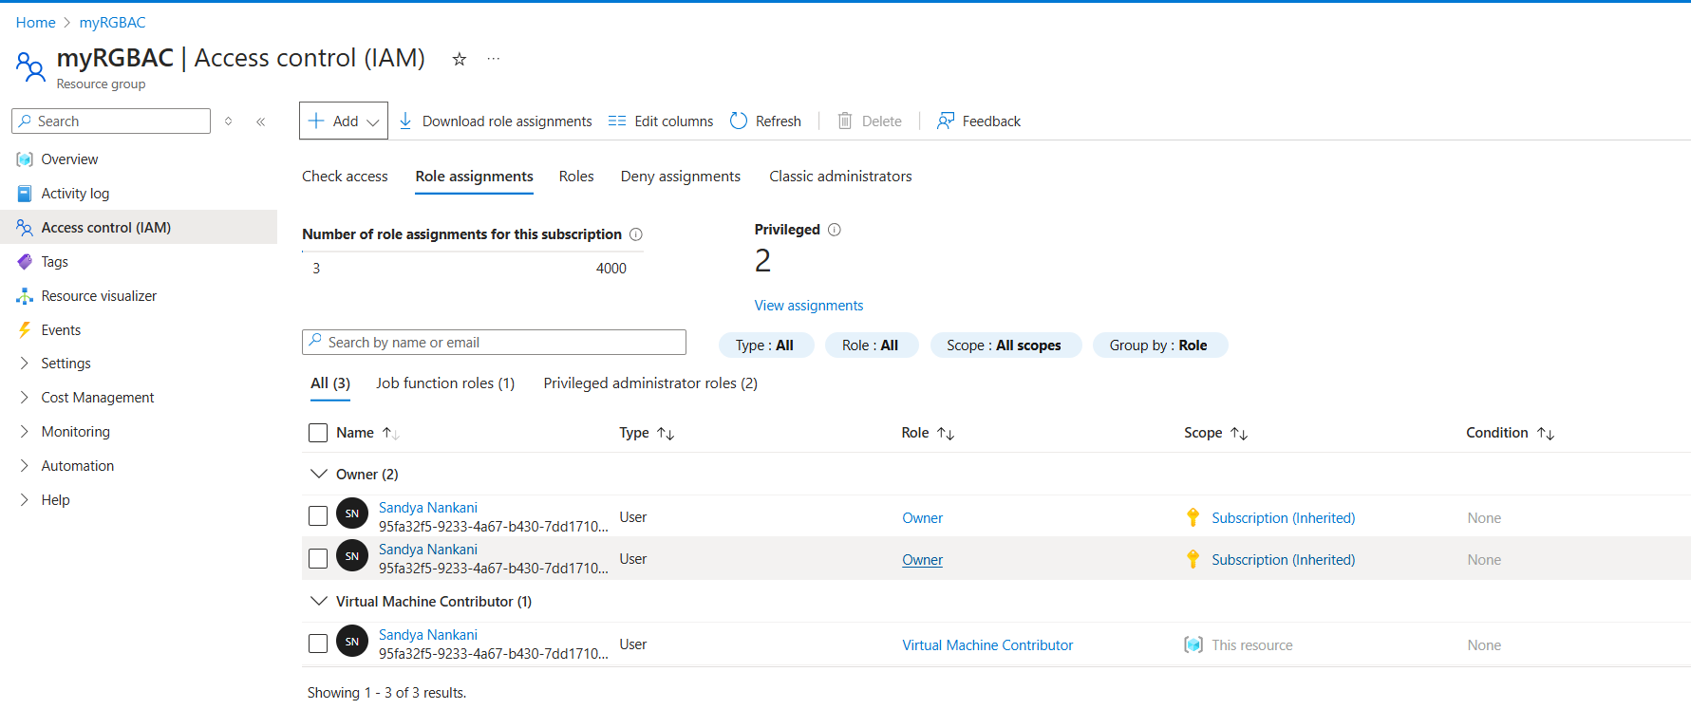

**Task 2:**

